During the Ceremony
Before the moment of Confirmation approaches, the Bishop may ask the Confirmation Sponsors together to stand in their places.
‘My dear sponsors, on behalf of the Christian Community, you are about to present these candidates for Confirmation. Do you promise to guide, support and encourage these friends of yours as they continue their journey of faith?’
They reply: ‘ I do.’
During the rite of Confirmation, Sponsors and their candidates come forward at the appointed time. Sponsors stand to the left of the candidate, and slightly behind, and place their right hand on the right should of the candidate. The Bishop usually greets both. After the Bishop has anointed the candidate with the oil of Chrism, both the confirmation sponsor and the candidate return to their places.
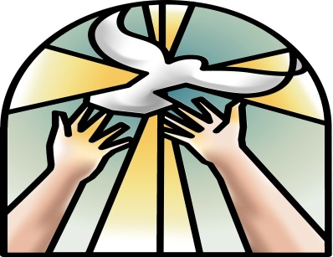
Being strengthened
To be confirmed is to be strengthened. This is what happens when the Bishop lays hands on the head of the candidate and anoints them with the Oil of Chrism. They are now able to take their spiritual lives more seriously, and are now being sent out filled with the Holy Spirit with a mission to spread the Gospel.

Confirmation Candidates
To be confirmed, Candidates must have been baptised and must not have received the Sacrament before. They are prepared through catechesis and prayer at home and at school. They will be asked to profess the Catholic Faith by renewing their baptismal promises. They will receive the sacrament of Penance before Confirmation day. They are called to be witnesses at home, in their parish, and in their ordinary daily life in the world
Diocese of waterford and lismore

BEING A SPONSOR
For a candidate
For THE SACRAMENT OF CONFIRMATION
Unique Bond
Being a Confirmation Sponsor is a wonderful honour and beautiful way to be part of the candidate’s life. Through Confirmation, sponsors and candidates are united in a unique bond that lasts through life.

What is Confirmation?
Baptism, Confirmation and the Eucharist are referred to as the three Sacraments of Initiation into the life of Christ and His Church and all three form a unity. They are the foundations of the Christian Life. Baptism is usually received shortly after birth, First Holy Communion is received at the age of eight and Confirmation in the early teenage years.
‘By the Sacrament of Confirmation, the baptised are more perfectly bound to the Church, and are enriched with a special strength of the Holy Spirit. They are true witnesses of Christ’
(Catechism of the Catholic Church 1285)
What is a Confirmation Sponsor?
It is an ancient tradition of the Church that for the Sacrament of Confirmation, a Sponsor is chosen. A Confirmation Sponsor is someone who will help the person being confirmed to live a good life as a true follower of Christ.
What does a Confirmation Sponsor do?
The first thing a sponsor must do is pray for the candidate and continue helping the candidate along the Christian road of life, to safeguard and develop the grace given at Baptism and now sealed with the gift of the Holy Spirit. The sponsor is called to be a support to that person not only on the day of Confirmation, but throughout his/her life.
Sponsors should give the candidate a good example of what it means to be a disciple of Christ and should take their own spiritual life seriously. This will be shown by their love of God, for the Word of God, for the Mass and the Sacraments, for the teachings of the Church, and by the love they show for others.
Who can be a Confirmation Sponsor?
The Sacrament of Confirmation is important and sponsors must be chosen carefully. Sometimes, one of the baptismal godparents is chosen as a Confirmation Sponsor. This clearly expresses the link between Baptism and Confirmation. If this is not possible another sponsor may be chosen.
A sponsor must be:
- Chosen by the candidate
- A confirmed and practicing Catholic
- At least sixteen years old
- In good standing with the Church, leading with a good life built on faith

