Trocaire – Ethiopian Visit Report by Mary Dee

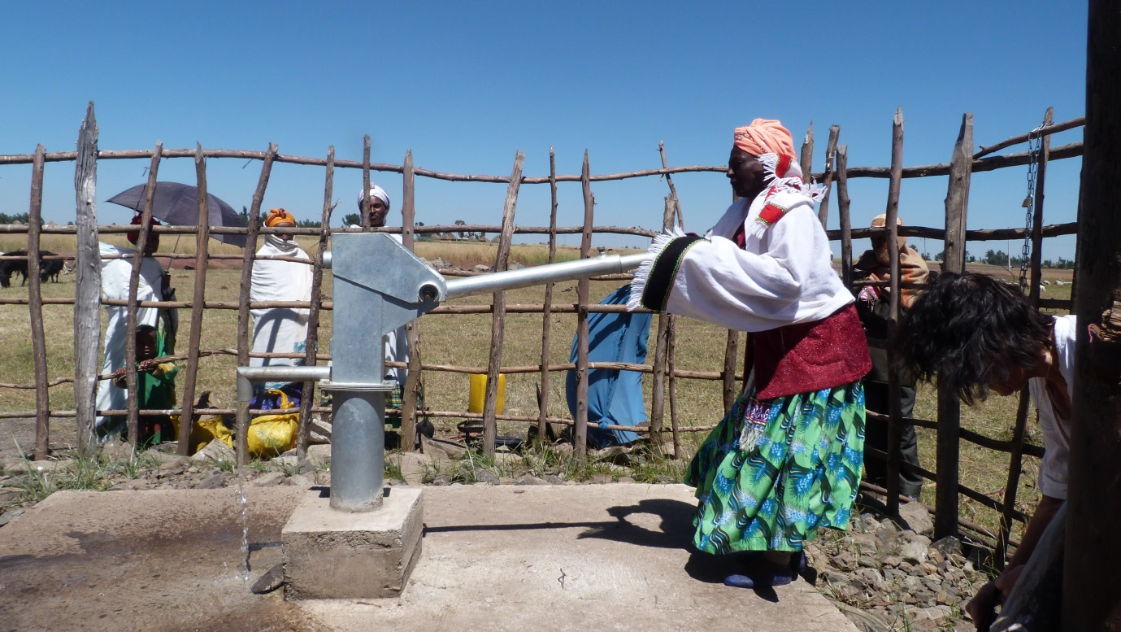

Pictured above is The Water Well

With only three weeks left in the Lenten campaign, I once again focus on another project that we visited during our Trocaire trip to Ethiopia last November.

On November 6th, we had a partner visit to HUNDEE, a livelihood enhancement programme of poor women in Jate. The location was Oromia region, Jate locality of Wuchale Woreda, 75 km from Addis Ababa, which was a 1.5 hour drive.

The project focuses on purchasing and distributions of improved breed of heifers to women-headed households who have demonstrated capability to manage livestock; the provision of different species of animal fodder, improved livestock breeds and animal health service. The project also provides improved market access for the production of milk. Main outcomes;
- Acquisition of new skills and knowledge on improved cattle management;
- Enhanced self-esteem and capability of target women to access new opportunities;
- New and strong relationships between the cooperative and other stakeholders relevant for dairy development;
- Reduced incidences of water borne diseases of target communities to access new opportunities of portable water that will contribute for healthy community

On arrival, we were met with a very big group of women, who were dressed in bright colours and were singing our welcome. This was a wonderful experience. Their singing and welcome was so special – the real sound of Africa.
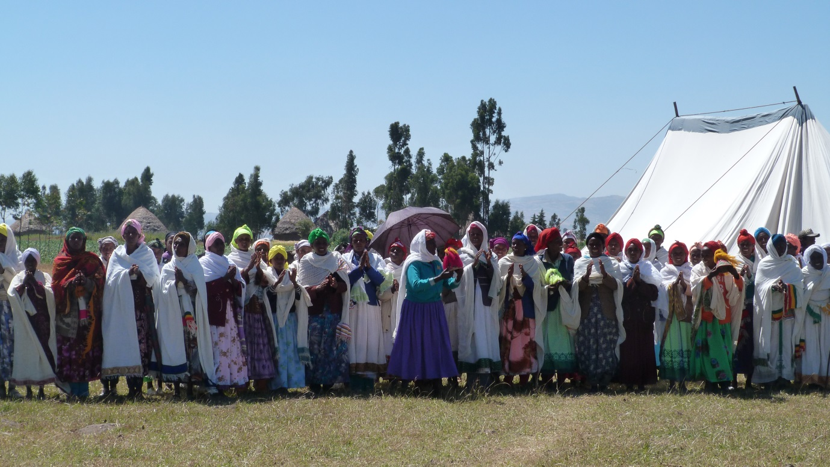
(The Choir of Welcome)

They took great pride in showing us their new water well. This was a great addition to their wellbeing and community.

After showing us the well, we then gathered in a specially erected tent for our visit, where the women told us their stories. One lady spoke about her heifer that was now expecting a calf. She was waiting patiently for the milk. The money that she will get from the milk will help her fund the education for the children. She told us of the ‘self help group’ that was formed. There are 25 in each group and the leadership of the group is rotated every few months, to encourage assertiveness among the women. They also use the ‘benefit in kind’ scheme where they sometimes swap a heifer for something else, depending on the family’s needs. They use a savings scheme where they borrow and save all the time. One lady started off with one sheep and now she has three. She also bought an ox for ploughing. This showed me their spirit and determination to make a better life for themselves.
This particular project again shows the difference that your contribution to the Trocaire Lenten campaign makes. Please do your very best with this year’s Trocaire Box. Boxes are now available in your local Church.
To find out more about Trócaire’s Lenten campaign or to make a donation log on to trocaire.org/lent.

