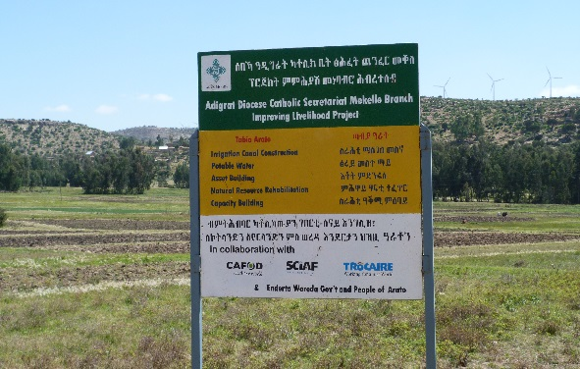
Project sign in Mekelle, Ethiopia
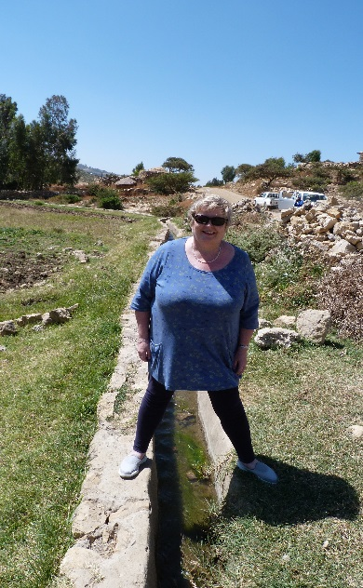
Mary Dee, pictured at the Water Irrigation Channel

Trocaire – Ethiopian Trip
As a follow on from last week’s report, I now focus on the Water Irrigation projects that are already up and running in Ethiopia for the last number of years.

Trocaire, with the help of the Catholic agencies CAFOD and SCIAF, funded water irrigation projects that are now completely run by the communities where they were provided in the Adigrat Diocese, in the Mekelle region. The water was diverted from a running stream, and waterways were built, with openings to allow the water flow into the very dry land. The young people look after the drains, ensuring that the water can flow freely at all times. They take great pride in this project that has given them so much.

It was a joy to see what they have achieved. They now successfully grow onions, tomatoes and other vegetables to help sustain the community. They also sell this produce at local markets.

During this visit, it was interesting to see a local farmer threshing in the fields. They had the wheat on the ground, and the horses were moving around in circles over the wheat. No agricultural machinery here!!

We received such a warm welcome from the community. They were waiting for our visit and treated us to native African dance and song.

Here in Ireland, we take water for granted every day of our lives. During this Lent, we might spare a thought for those who are less fortunate than ourselves, and need water and a rainy season for their crops to grow and give them their livelihood.

Please do your very best with this year’s Trocaire Box. Boxes are now available in your local Church.

To find out more about Trócaire’s Lenten campaign or to make a donation log on to trocaire.org/lent.

